Water
This is the ontological representation of Toronto’s water distribution service, including both the physical distribution infrastructure and ward-level service metrics (consumption and capacity). The overall service is represented as an instance of the WaterService class (tor:waterservice). Water distribution pipes are represented as site-like entities linked from the service via providedFromSite, where each pipe can have a unique identifier (via hasIdentifier) and a geospatial location (via hasLocation) expressed as WKT geometry (via asWKT).
To model how water service performance varies across the city, the water service is decomposed into ward-level sub-services (for a given year), linked using hasSubService. Each ward sub-service is associated with a ward catchment area using hasCatchmentArea, where the catchment’s geometry is defined using the ward’s existing location in the knowledge graph. Consumption, total capacity, and available capacity are represented as quantitative rate objects (as instances of WaterDistributionRate) with values captured through ISO measurement structure (hasValue, hasNumericalValue, hasUnit) in m³/year.
This section summarizes how the Watermains dataset (geometry and assets), water billing by ward (annual consumption), synthetic capacity by ward (total and available capacity), and ward locations (catchment geometry) are mapped into the City Digital Twin ontology.

The following is a list of namespace prefixes used in the mappings and ontology definitions that follow:
- tor: http://ontology.eil.utoronto.ca/Toronto/Toronto#
- genprop: https://standards.iso.org/iso-iec/5087/-1/ed-1/en/ontology/GenericProperties/
- loc: https://standards.iso.org/iso-iec/5087/-1/ed-1/en/ontology/SpatialLoc/
- geo: http://www.opengis.net/ont/geosparql#
- hp: http://ontology.eil.utoronto.ca/HPCDM/
- service: https://standards.iso.org/iso-iec/5087/-2/ed-1/en/ontology/CityService/
- org: https://standards.iso.org/iso-iec/5087/-2/ed-1/en/ontology/Organization/
- contact: https://standards.iso.org/iso-iec/5087/-2/ed-1/en/ontology/Contact/
- res: https://standards.iso.org/iso-iec/5087/-1/ed-1/en/ontology/Resource/
- cdt: http://ontology.eil.utoronto.ca/CDT#
- i72: http://ontology.eil.utoronto.ca/ISO21972/iso21972#

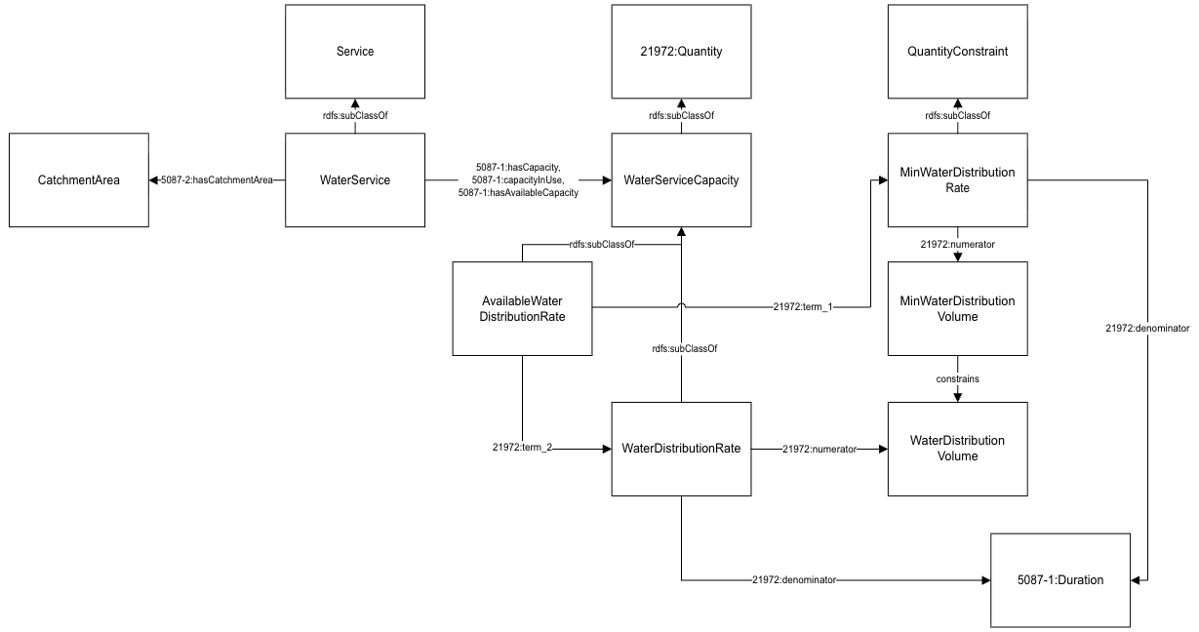
Figure 1: Diagram of Water Pattern.

Data Provided by Watermains Dataset
Field Name | Subject | Property | Object | Notes
_id | tor:waterservice | rdf:type | tor:TorWaterService | Unique row identifier for Open Data database
 | tor:waterservice | hp:providedFromSite | tor:waterservice_ distributionpipes{_id}
Watermain Asset Identification | tor:waterservice_ distributionpipes{_id} | genprop:hasIdentifier | "{Watermain Asset Identification}" | Identification number assigned by the City of Toronto
 | tor:waterservice_ distributionpipes{_id} | loc:hasLocation | tor:waterservice_ distributionpipes_loc{_id}
geometry | tor:waterservice_ distributionpipes_loc{_id} | geo:asWKT | "{geo}" | Geometry.
Table 1: Mapping Watermains Data to City Digital Twins

Data Provided by Ward Locations Dataset
Field Name | Subject | Property | Object | Notes
loc | tor:water_distributionservice _ward_catchment{Ward} | loc:hasLocation | {loc} | parse the tor:{ward} value for {s} to generate the ward number needed for {Ward} in tor:water_distributionservice_ward_catchment{Ward}
Table 2: Mapping Ward Locations Data to City Digital Twins
Toronto Watermain locations interpreted as service sites (sites of the distribution service). While no catchment areas are specified, nor is service defined for individual water connections, it is possible to use the service site locations to approximate service accessibility (based on some reasonable proximity, e.g., 30 m)
Watermains, specifically, "distribution" dataset; note that there is other data that could be useful for extensions to this work; emailed OpenData contact for interpretation of "Watermain Type" field in case this could/should be used for filtering

Data Provided by Water Billing Dataset
Field Name | Subject | Property | Object | Notes
Ward | tor:waterservice | hp:hasSubService | tor:water_distribution service_ward{Ward}_{Year} | 2-digit electoral ward number  Services are activites, so a "sub-service" is simply a subactivity of the service
 | tor:water_distribution service_ward{Ward}_{Year} | rdf:type | tor:TorWaterService
 | tor:water_distribution service_ward{Ward}_{Year} | service:hasCatchmentArea | tor:water_distribution service_ward_ catchment{Ward}
Year | tor:water_distribution service_ward{Ward}_{Year} | change:existsAt | tor:interval_{year} | Year in yyyy format
 | tor:interval_{year} | time:hasBeginning | tor:instant_{year}_start
 | tor:interval_{year} | time:hasEnd | tor:instant_{year}_end
 | tor:instant_{year}_start | time:inXSDDateTimeStamp | {year}-01-01T00:00:00-05:00
 | tor:instant_{year}_end | time:inXSDDateTimeStamp | {year}-12-31T23:59:59-05:00
Total consumption (m3) | tor:water_distributionservice_ ward {Ward}_{Year} | res:capacityInUse | tor:water_distribution  service_ward {Ward}_{Year}_capacityuse | Total annual usage
 | tor:water_distributionservice_ ward {Ward}_{Year}_capacityuse | rdf:type | hp:WaterDistributionRate
 | tor:water_distributionservice_ ward {Ward}_{Year}_capacityuse | i72:hasValue | tor:water_distribution service_ward{Ward}_  {Year}_capacityuse_ measure
 | tor:water_distributionservice_ ward{Ward}_{Year}_capacityuse_measure | i72:hasNumerical Value | "Total consumption (m3)"
 | tor:water_distributionservice_ ward{Ward}_{Year}_capacityuse_measure | i72:hasUnit | hp:cubic_meter_per_ year
Table 3: Mapping Water Billing (by ward) Data to City Digital Twins
Toronto Water billing by ward provides a measure of capacity use
In this case, wards are simply used as a means of aggregating water usage.
We can interpret this data as providing usage for sub-services of the city-wide water distribution service, where the water distribution is broken down by ward
This data gives us an annual consumption rate though in theory the numbers should be available e.g. per day per region.

Data Provided by Water Capacity Dataset
Field Name | Subject | Property | Object | Notes
Synthetic Capacity | tor:water_distribution  service_ward{Ward}_{Year} | res:hasCapacity | tor:water_distribution  service_ward{Ward}_{Year}_Capacity | use measured in m3/year
 | tor:water_distribution  service_ward{Ward}_{Year}_Capacity | rdf:type | hp:WaterDistributionRate
 | tor:water_distribution  service_ward{Ward}_{Year}_Capacity | i72:hasValue | tor:water_distribution  service_ward{Ward}_{Year}_CapacityMeasure
 | tor:water_distribution  service_ward{Ward}_{Year}_Capacity  Measure | i72:hasNumericalValue | "{Synthetic Capacity}"
 | tor:water_distribution  service_ward{Ward}_{Year}_Capacity  Measure | i72:hasUnit | hp:cubic_metre_per_year
Synthetic Available Capacity | tor:water_distribution  service_ward{Ward}_{Year} | res:hasAvailableCapacity | tor:water_distribution  service_ward{Ward}_{Year}_AvailCapacity | use measured in m3/year
 | tor:water_distribution  service_ward{Ward}_{Year}_Avail  Capacity | rdf:type | hp:AvailableWaterDistributionRate
 | tor:water_distribution  service_ward{Ward}_{Year}_Avail  Capacity | i72:hasValue | tor:water_distribution  service_ward{Ward}_{Year}  _AvailCapacityMeasure
 | tor:water_distributionservice_ward {Ward}_{Year}_AvailCapacityMeasure | i72:hasNumericalValue | "{Synthetic Available Capacity}"
 | tor:water_distributionservice_ward {Ward}_{Year}_AvailCapacityMeasure | i72:hasUnit | hp:cubic_metre_per_year
Table 4: Mapping Water Capacity Data to City Digital Twins

Implementation of Water Data in Mapping TTL
Script: Water&Water_Capacity.py
URI strategy
The script generates deterministic URIs under the tor: namespace so that pipes and ward-year services can be referenced consistently:
- City-wide service: tor:waterservice
- Distribution pipe (per asset row): tor:waterservice_distributionpipes{_id}
- Pipe location node: tor:waterservice_distributionpipes_loc{_id}
- Ward-year distribution sub-service: tor:water_distributionservice_ward{Ward}_{Year}
- Ward catchment area: tor:water_distributionservice_ward_catchment{Ward}
- Annual time interval/instants:
  - tor:interval_{Year}
  - tor:instant_{Year}_start, tor:instant_{Year}_end
- Consumption (capacity-in-use) rate + measure:
  - tor:water_distributionservice_ward{Ward}_{Year}_capacityuse
  - tor:water_distributionservice_ward{Ward}_{Year}_capacityuse_measure
- Total capacity + measure:
  - tor:water_distributionservice_ward{Ward}_{Year}_Capacity
  - tor:water_distributionservice_ward{Ward}_{Year}_CapacityMeasure
- Available capacity + measure:
  - tor:water_distributionservice_ward{Ward}_{Year}_AvailCapacity
  - tor:water_distributionservice_ward{Ward}_{Year}_AvailCapacityMeasure

Inputs
- Watermain geometry + identifiers
  - Distribution Watermain - 4326.csv
  - Required fields used:
    - _id (for URI construction)
    - Watermain Asset Identification (identifier literal)
    - geometry (GeoJSON string converted to WKT)
- Ward-year consumption (water billing)
  - Water_Consumption_YYYY.xls/xlsx files (script is written to iterate across many years)
  - Required columns (names vary by file, script matches flexibly):
    - City ward
    - Year
    - Total consumption
- Ward-year synthetic capacity
  - Water_Consumption_Capacity_2020(Water_Consumption_2020).csv
  - Required columns:
    - city ward, year
    - Synthetic Capacity
    - Synthetic Available Capacity
- Ward locations (for catchment geometry)
  - The script queries the existing City Digital Twin knowledge graph (GraphDB SPARQL endpoint) to retrieve Ward instances and their hasLocation nodes (and geo:asWKT), so catchment areas inherit the ward geometry for Toronto.
Outputs
- water.ttl
Contains: water service, distribution pipes + their geometries, ward-year sub-services, catchment-area links, annual time intervals, and ward-year consumption (capacity in use).
- water_capacity.ttl
Contains: ward-year total capacity and available capacity measures.
Step-by-step process
Step 1 - Initialize RDF graphs and namespaces
Two RDF graphs are created:
- g for the core water service + pipes + ward-year consumption
- capacity_g for ward-year (total/available) capacity values
Namespaces are bound (e.g., tor:, hp:, loc:, geo:, res:, i72:, service:, change:, time:).
Step 2 - Create the top-level WaterService instance
tor:waterservice is created and typed as tor:TorWaterService.
Step 3 - Create catchment areas by linking to existing Ward geometries
The script runs a SPARQL query to retrieve each toronto:Ward and its iso50871:hasLocation. For each ward:
- A catchment URI (tor:water_distributionservice_ward_catchment{Ward}) is created.
- The catchment is linked to the ward’s location node via loc:hasLocation.
- The ward location’s geo:asWKT is also pulled and asserted in the output graph so the geometry is present for downstream use.
Step 4 - Map distribution pipes (watermains) with geometry
For each row in Distribution Watermain - 4326.csv:
- A pipe node tor:waterservice_distributionpipes{_id} is created.
- The pipe is linked from the service using hp:providedFromSite.
- The asset identifier is stored using genprop:hasIdentifier.
- A location node is created and linked using loc:hasLocation.
- The GeoJSON LineString / MultiLineString is converted into a WKT LINESTRING(...) and stored via geo:asWKT on the location node.
Step 5 - Map ward-year consumption as capacity-in-use with time interval
For each year file in the consumption list:
- The script detects the ward/year/total consumption columns (even if they include newlines/spaces).
- For each valid ward-year row:
  - Create the ward-year distribution service tor:water_distributionservice_ward{Ward}_{Year}.
  - Link it from tor:waterservice using hp:hasSubService.
  - Link it to the ward catchment using service:hasCatchmentArea.
  - Add a temporal interval for the year using change:existAt pointing to tor:interval_{Year}, with beginning/end instants (Jan 1 to Dec 31 timestamps).
  - Represent consumption as a hp:WaterDistributionRate linked by res:capacityInUse, with ISO 21972 measurement structure:
    - i72:hasValue → measure node
    - i72:hasNumericalValue → consumption number
    - i72:hasUnit → hp:cubic_metre_per_year
Step 6 - Map synthetic total and available capacity
For each ward-year row in the capacity CSV:
- The script creates two rate nodes:
  - total capacity linked via res:hasCapacity
  - available capacity linked via res:hasAvailableCapacity
- Each is typed as hp:WaterDistributionRate and recorded with:
  - i72:hasValue → measure node
  - i72:hasNumericalValue → parsed numeric value (commas removed)
  - i72:hasUnit → hp:cubic_metre_per_year
Step 7 - Serialize TTL
The graphs are written to:
- water.ttl
- water_capacity.ttl
Notes / assumptions
- Catchment geometries depend on the SPARQL endpoint being reachable; if the ward location lookup fails, catchment areas may be missing geometry/location triples.
- Pipe geometry conversion assumes the geometry column is valid GeoJSON for LineString or MultiLineString.
- All ward-year rates are stored in m³/year (hp:cubic_metre_per_year).
- Annual interval timestamps are generated in an explicit -05:00 offset in the script.

